**File Upload Page (Self Service/OAF page)  
  
Deployment Steps  
  
Step 1:** Run LDT **XX_FILE_UPLOAD_PROFILE.ld**t as per the instructions given in Migration Doc

**Step 2**: Create Directory Structure under $JAVA_TOP for placing .class and .xml files  
   
1.1 Navigate to the path $JAVA_TOP

(Path would be like: /u01/oracle/EBSDEV/apps/apps_st/comn/java/classes)

1.2 Create the following directory structure at this path:

* /u01/oracle/EBSDEV/apps/apps_st/comn/java/classes**/xx_custom/oracle/apps/chcus/upload/server**
* /u01/oracle/EBSDEV/apps/apps_st/comn/java/classes**/xx_custom/oracle/apps/chcus/upload/webui**

For e.g.  
  
 [appldev@ebsdevapp01 classes] mkdir xx_custom  
 [appldev@ebsdevapp01 classes] cd xx_custom  
 [appldev@ebsdevapp01 xx_custom] mkdir oracle  
 [appldev@ebsdevapp01 xx_custom] cd oracle  
 [appldev@ebsdevapp01 oracle] mkdir apps  
 [appldev@ebsdevapp01 oracle] cd apps …And so on till upload directory is created.   
  
 **In upload directory create two sub directories – server & webui**

[appldev@ebsdevapp01 upload] mkdir server  
 [appldev@ebsdevapp01 upload] mkdir webui

**Step 3:** Transfer the files to Unix Server as per below mentioned points:

Note: Please transfer **.class** files in **Binary Mode** and **.xml** files in **ASCII mode.**

|  |  |  |
| --- | --- | --- |
| **File Name** | **Path on Unix Server where the files to be placed** | **Transfer Mode** |
| FileUploadPG.xml | $JAVA_TOP/ chcus/oracle/apps/chcus/upload/webui | ASCII |
| FileUploadCO.class | $JAVA_TOP/ chcus/oracle/apps/chcus/upload/webui | Binary |
| xxFileUploadAM.xml | $JAVA_TOP/ chcus/oracle/apps/chcus/upload/server | ASCII |
| server.xml | $JAVA_TOP/ chcus/oracle/apps/chcus/upload/server | ASCII |
| xxFileUploadAMImpl.class | $JAVA_TOP/ chcus/oracle/apps/chcus/upload/server | Binary |

As a summary, 2 files (one .class and one .xml) should go in webui directory and 3 files should go in server directory**.**

**Very Important: After placing files, please change the permission of these files:**

[appldev@ebsdevapp01 **webui**] chmod 777 FileUploadPG.xml  
 [appldev@ebsdevapp01 **webui**] chmod 777 FileUploadCO.class  
  
 [appldev@ebsdevapp01 **server**] chmod 777 xxFileUploadAM.xml  
 [appldev@ebsdevapp01 **server**] chmod 777 server.xml  
 [appldev@ebsdevapp01 **server**] chmod 777 xxFileUploadAMImpl.class

**Step 4:** Navigate to the path $JAVA_TOP and run the following command.   
*Please change the details of the bold highlighted part depending upon the environment.*  
 adjava oracle.jrad.tools.xml.importer.XMLImporter $JAVA_TOP/chcus/oracle/apps/chcus/upload/webui/FileUploadPG.xml -rootdir $JAVA_TOP/ -username apps -password apps -dbconnection "(DESCRIPTION=(ADDRESS=(PROTOCOL=tcp)(**HOST=<>)(PORT=<>))(CONNECT_DATA=(SID=<>)))"**

**Step 5:** Run LDT **XX_CUST_FILE_UPLOAD.ldt** as per the instructions given in Migration Doc

Navigate to Application Developer -> Application -> Function

Query the function: CH_FILE_UPLOAD for confirmation 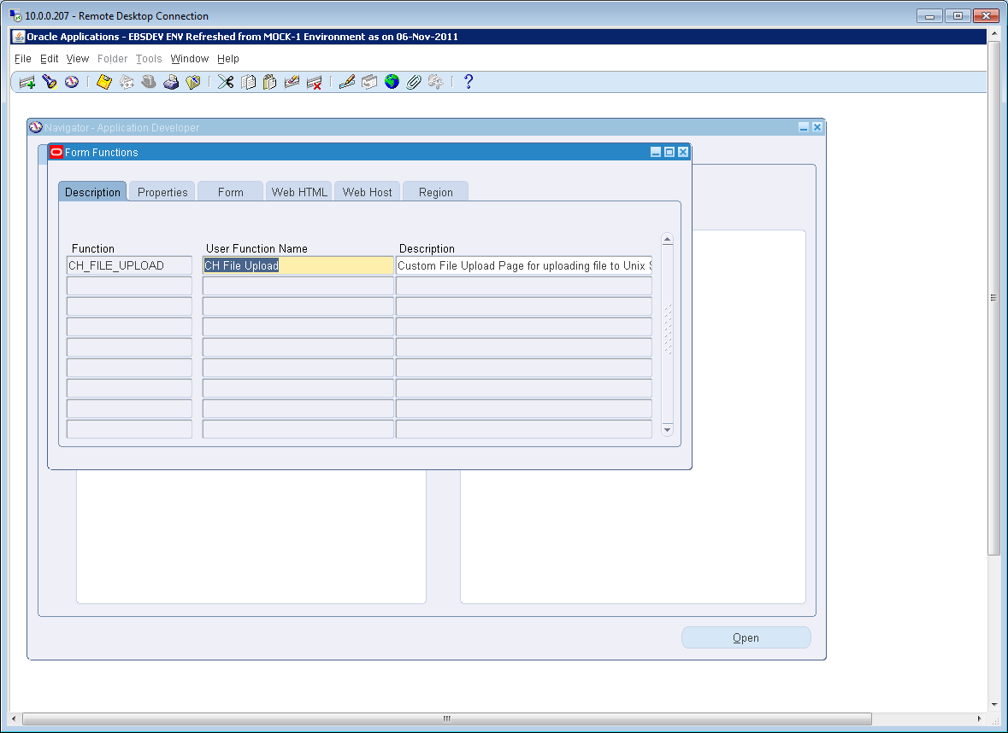

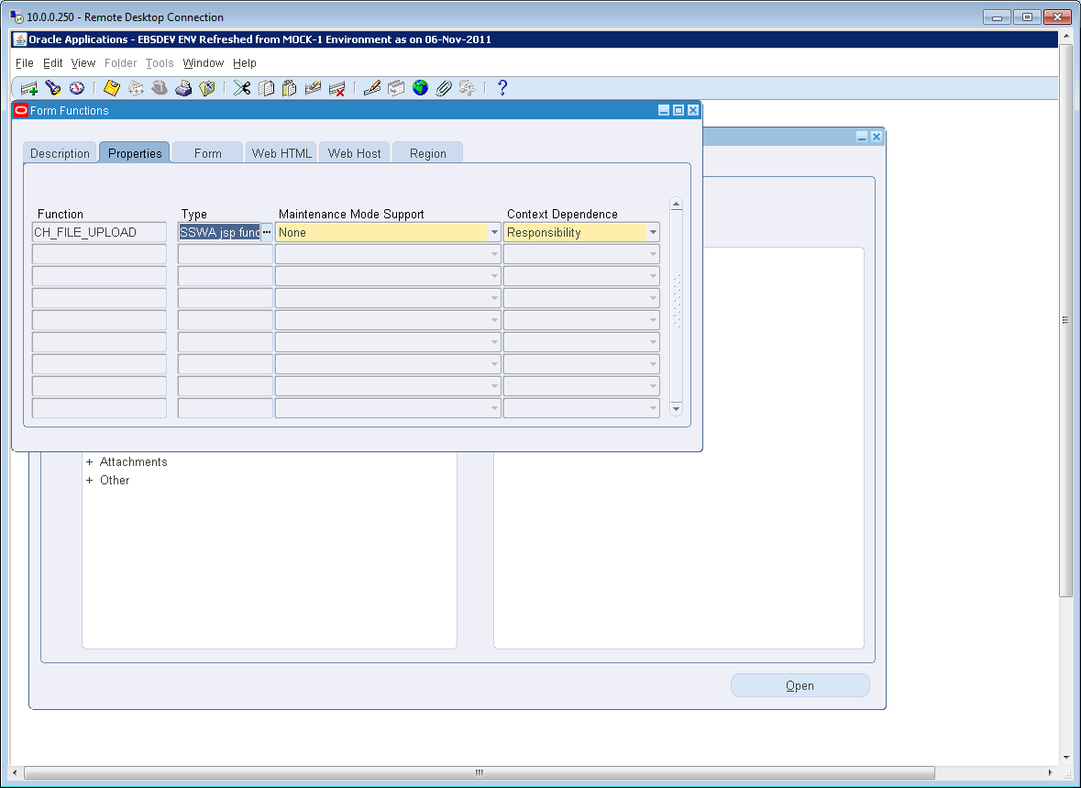

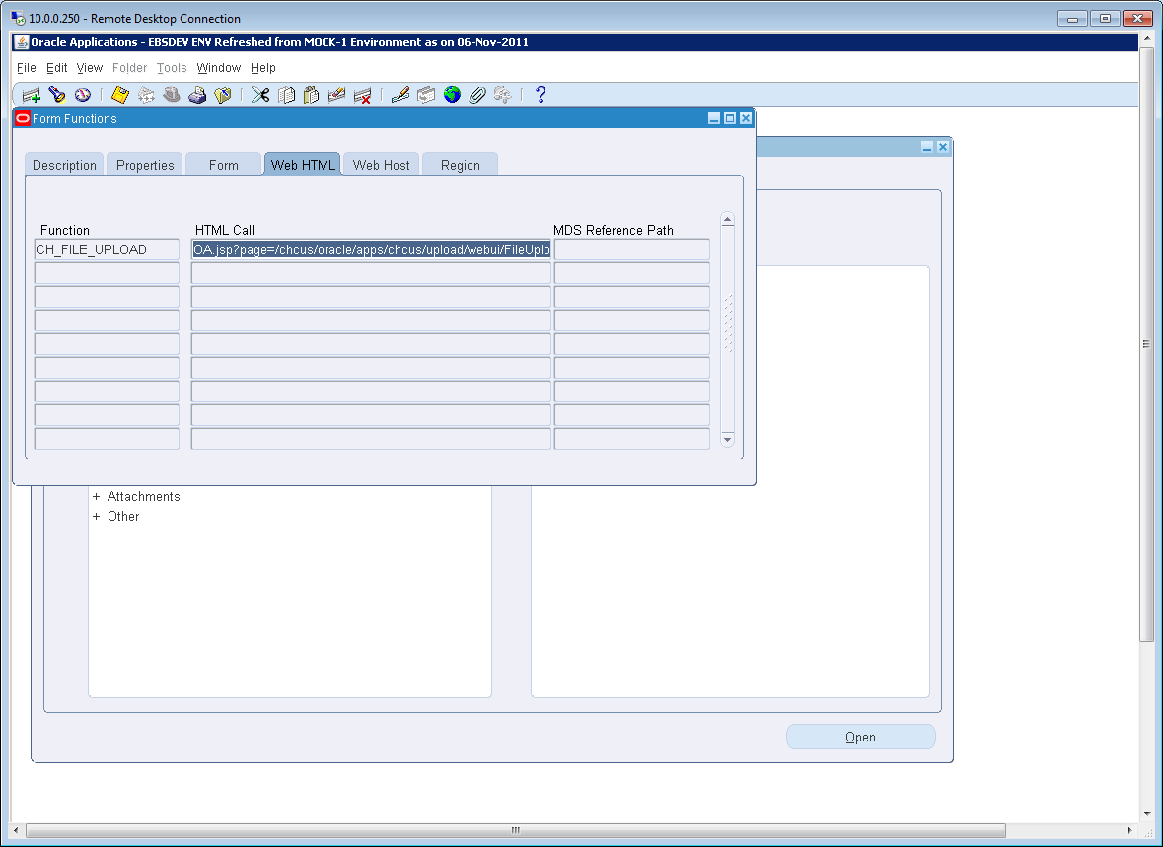

**Step 6:** Attach the function **‘CH_FILE_UPLOAD’** to Menu **CHCUS_CUSTOM_MENU**  